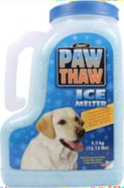

2022 McLean Crew Club

Fresh Holiday Evergreens and Paw Thaw Sale

Hello friends and neighbors,

As you may know, I am a member of the McLean Crew Club. Our winter conditioning starts soon, and I'm excited about the season. Unfortunately, because we are a club, we receive no funding from Fairfax County Public Schools, and all rowers need to work hard to raise funds to maintain equipment and help keep membership fees manageable for students.

If you are planning to purchase seasonal greenery or ice melt this year, can you please order through me? This year, we will be selling:

- PREMIUM FRESH EVERGREENS, including door sprays, tabletop trees, centerpieces, and more! Fresh and fragrant, these evergreens are the perfect decorations for your home and gifts for your loved ones and friends. All evergreens will be shipped directly to you and your giftees!

- PAW THAW: pet-safe, biodegradable ice melt packaged in 12lbs jugs with a convenient shake top! This non-hygroscopic formula is water soluble, odorless, and less harmful to vegetation. Rowers will be delivering Paw Thaw directly to customers!

Please visit https://www.mcleancrew.org/fall-winter-fundraisers to order and to learn more about the products!

Thank you so much for your support and Happy Holidays!

